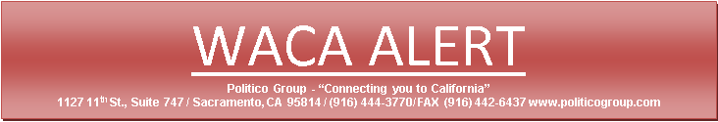

**Public Works Change Order Reform Extension Sent to Governor Newsom – Take Action**

The WACA supported change order reform measure, AB 456, which extends the sunset in Public Contract Code §9204 has been sent to Govenar Newsom for his consideration. The original measure, AB 626 (Chui – 2016), closed a loophole in California’s public works prompt payment laws.  That section of law provides California public works contractors an avenue to pursue prompt payment for extra work performed. Specifically, Public Contract Code §9204 requires public agencies to respond to a contractor’s claim for extra work ordered by the agency, to pay out portions of the work they acknowledge and/or agree they owe the contractor, and implements a fair process for resolving any disputed portions of amounts owed. Unless the sunset date in Public Contract Code §9204 is extended, the fair process that has decreased construction delays, cut costs on California’s public works projects, and reduced litigation to the benefit of the industry and taxpayers will expire.

A copy of the law can be found here: <http://leginfo.legislature.ca.gov/faces/codes_displaySection.xhtml?lawCode=PCC&sectionNum=9204>.

We ask that you please take a moment and place the attached draft letter on your letterhead and email a copy of the letter to the email addresses below:

[leg.unit@gov.ca.gov](mailto:leg.unit@gov.ca.gov)

[Severiano.Christian@asm.ca.gov](mailto:Severiano.Christian@asm.ca.gov)

[politicoonline@politicogroup.com](mailto:politicoonline@politicogroup.com)

+++++++++++++++++++++++++++++++++++++++++++++++++++++++++++++++++++++++++++++++++++++

DATE

The Honorable Gavin Newsom

Governor, State of California

State Capitol

Sacramento, CA  95814

RE:   AB 456 (Chiu) – Request for Signature

Dear Governor Newsom,

On behalf of INSERT YOUR COMPANY NAME HERE, I am pleased to express our strong support for AB 456 relating to payment on public works projects and urge your signature on the bill.

AB 456 extends the sunset in Public Contract Code §9204 which closed a loophole in California’s public works prompt payment laws.  That section of law provides California public works contractors an avenue to pursue prompt payment for extra work performed that is fair and protects taxpayers.

Timely resolution of disputes on public construction projects benefits both the public agency owners and the contractors that perform the work. Delays in resolving disputes is costly to all involved and for that reason the issue was addressed in 2016 with the passage of AB 626, but that law expires on January 1, 2020.

Unless the sunset date in Public Contract Code §9204 is extended, the fair process that has decreased construction delays, cut costs on California’s public works projects, and reduced litigation to the benefit of the industry and taxpayers will expire. This would eliminate a thoughtfully negotiated policy that covered public agencies removed their opposition from during the original bill’s passage.

Continuing this policy is of critical importance to the California construction industry and for that reason we request your signature on AB 456.

Sincerely,

YOUR NAME

cc:          Assembly Member Chiu